**Optimisation Techniques for Performance Lawn Equipment (PLE)**

Linear optimisation model is used for optimising profile for PLE. The goal is to maximize the Objective Function i.e. Profit from the housing production.

There are six functional constraints and no non-negativity constraints present in this model. A feasible solution is obtained as all the constraints are satisfied through solver.

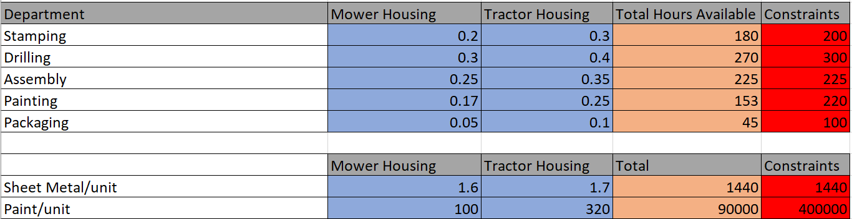

The assumed values for the decision variables i.e., number of units produced for Mower and Tractor housing is 1. The optimum solution obtained for the decision variables are 900 for Mower Housing and 0 for Tractor Housing so that the profit is maximum which is obtained as EUR 171000.

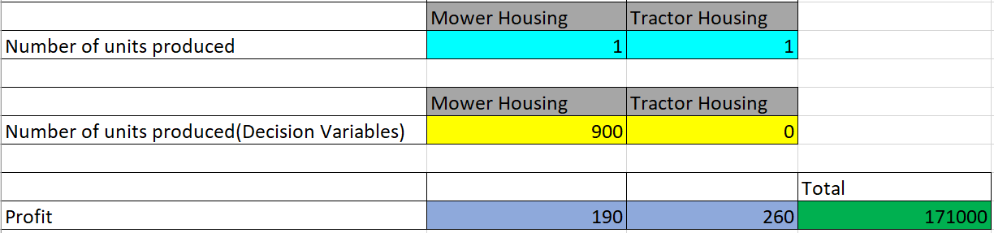

If the integer constraint is put on to the decision variables then only one Answer report is generated.

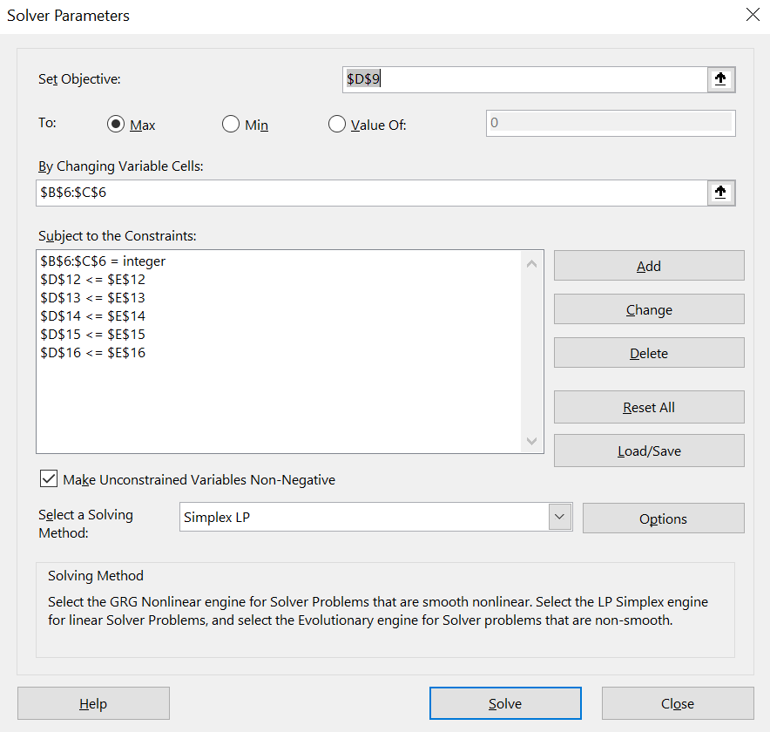

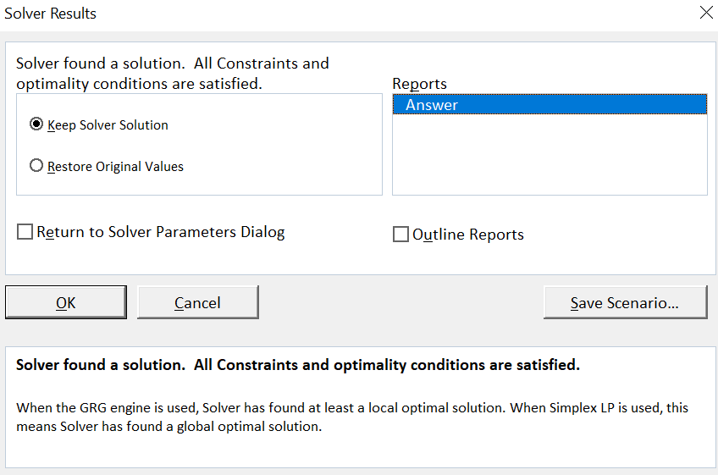

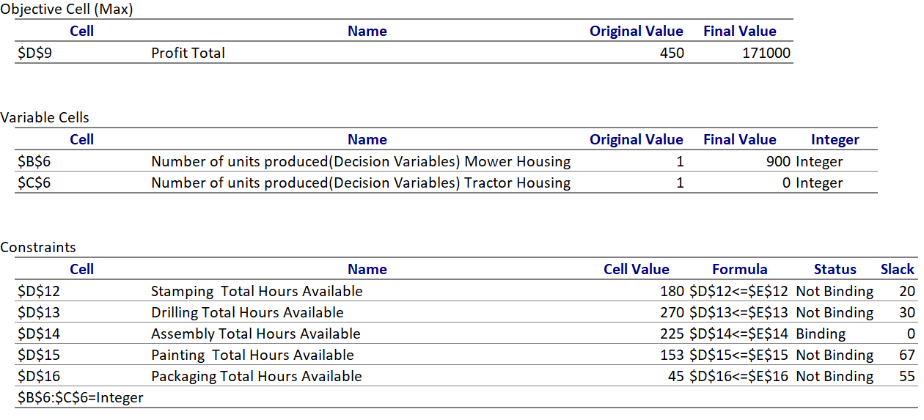

**Answer Report-** This report is generated when solver finds the optimal solution produced by the solver and the solution cannot be improvised thereafter.

1. The first part of the report i.e. Objective Cell(Max), signifies the Objective Function(Profit) which was maximised from 450 to 171000 by the solver.
2. The second part of the report i.e., Variable Cells, signifies that the number of units produced for Mower Housing has an optimum solution of 900 whereas the number of units produced for Tractor Housing has an optimum solution of 0 in order to maximise the profit. Also since the decision variables have been given a constraint to be integer ,‘Integer’ is present in the last column.
3. The third part of the report i.e., constraints, signifies the Cell Value i.e. the optimal total value calculated by the solver. The status ‘Binding’ indicates that during solver run, it has reached the maximum limit i.e. constraint’s value whereas ‘Not Binding’ indicates that it has not reached the maximum limit. Slack measures the difference between a Not Binding value and the constraint value.

However if the integer constraints are removed then three reports are generated namely Answer, Sensitivity and Limit reports.

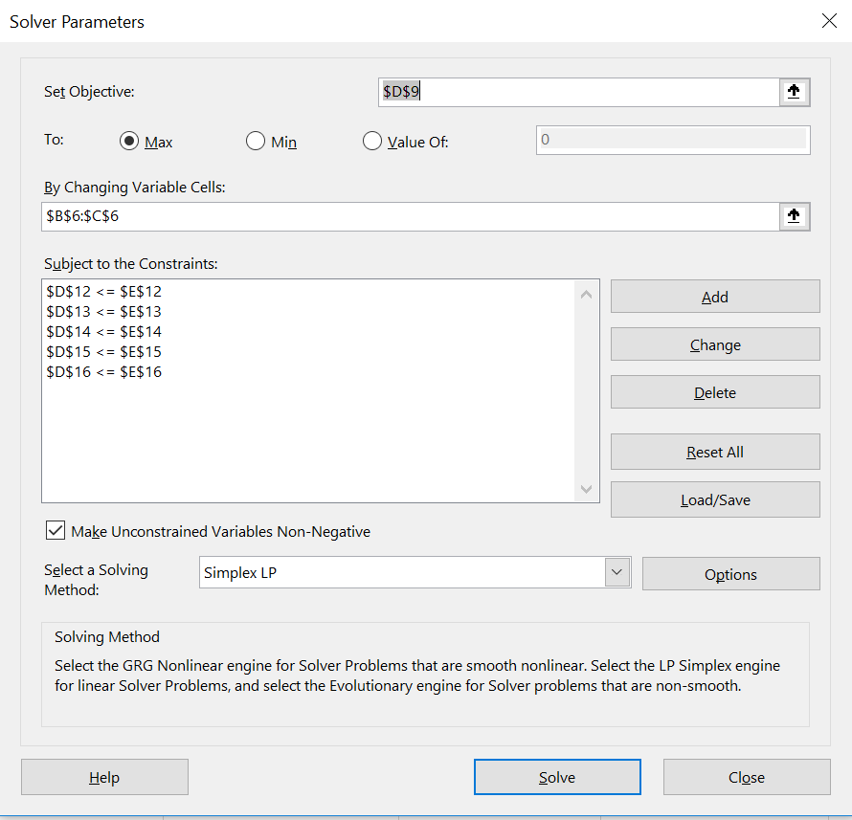

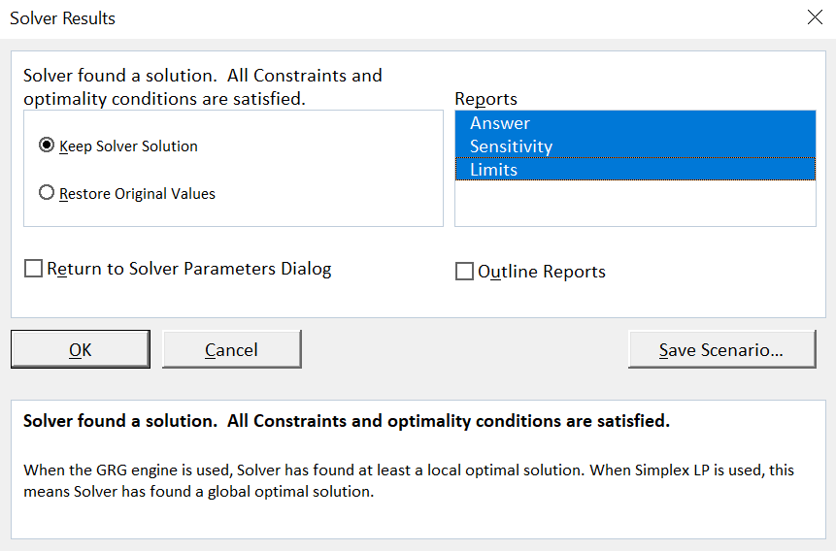

Answer report will be the same except the integer column in case of Variable Cells will be now Contin.

**Limit Report-** This report is generated when solver finds either best possible solution that satisfy all the value for constraints i.e. Globally Optimum or best nearby solution that satisfy all the value for constraints i.e. Locally Optimum.

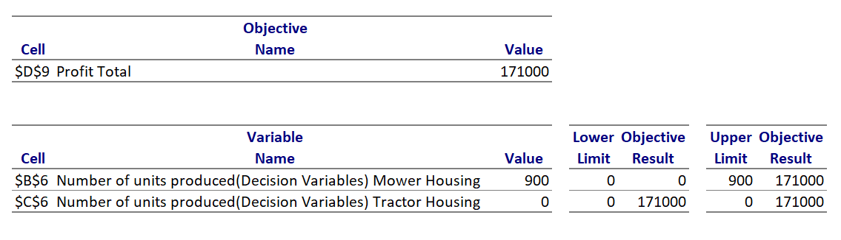

1. The first part of the report signifies the maximised profit (Objective Function) obtained through solver.
2. The second part of the report signifies the upper and lower limit which is taken by each decision variables having the fact that all other decision variables and the objective are kept constant.(Doubtful about the Objective Result part)

**Sensitivity Report-**(Check this once not sure my understanding is correct or not) This report is generated with the same criteria as Limit Report.

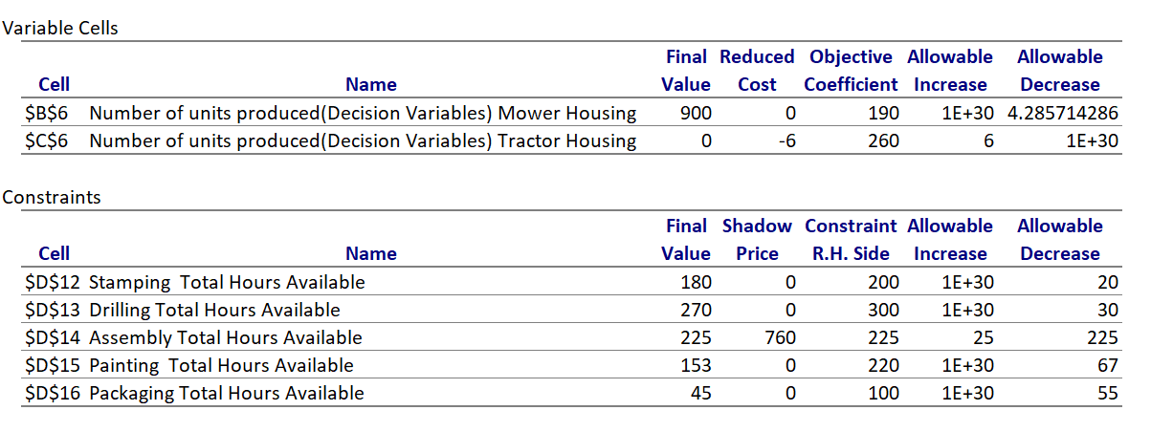

1. The first part of the report signifies i.e. Variable Cells, Reduced Cost is 0 if the optimum value of a decision variable is non-zero and vice-versa. However the negative value of Reduced Cost signifies how much binding constraint should be relaxed i.e. in this case increasing the number of hours in some departments for Tractor Housing, so as to maximise Objective Function(profit) to a better extent. Reduced Cost is nothing but an opportunity cost which indicates by changing the Binding variables, improvement in Objective Function can be achieved. Objective Coefficient indicates the original coefficient value of decision variable in Tractor Housing and Mower Housing. Allowable Increase and Decrease is a range which shows how much the Objective Coefficient can be changed without affecting the Reduced Cost.
2. The second part of the report i.e. Constraints signifies, Shadow Price is 0 if it is a ‘Not Binding’ Constraint else it indicates how much ‘Binding Constraint’ can be changed so as to improve the Objective Function. Constraint R.H. side indicates the constraint value. Allowable Increase/Decrease is a range which shows how much R.H side value can be changed without affecting Shadow Price.

If either mowers or tractors are not recommended to be produced, what would make the company to start producing them? – If the cost of producing either of the tractors or mowers goes significantly down as a result of either the usage of paint or the metal sheets goes down. It will also be recommended of the profit margin for any of them goes significantly higher.

What would happen if a fraction of the production is returned for re- painting due to defects and a number of buckets of paint cannot be used due to expiry date. - If a fraction of the production is returned due to a defect, then try to figure out if re-production of these items will be a feasible option, taking into consideration the number of non-usable paint buckets. If it’s a feasible option then reproduce them. If not, try to find out that what amount of re-production is a feasible option. Or if re-production is not a feasible option at all for the company. The feasibility of production should be measured before taking any decisions of re-production.

if the PLE manager considers allowing the workforce to work additional hours at an overtime premium of €X per hour, would this be a good suggestion? – It can be a good suggestion depending upon the value of EUR X per hour, the number of employees working overtime and the hours they will be working for. Paying for the overtime done by each employee should be considered and a new model should be created just to incorporate these changes in the payment system and the working hours. Study that model to see if it will be a feasible option.